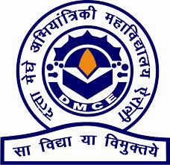

**DATTA MEGHE COLLEGE OF ENGINEERING**

Plot no 98, Cidco, Sector-3 Post Box No.15 Airoli, Navi Mumbai-400708

**CERTIFICATE**

This is to certify that

NAMES OF STUDENTS GR No.

1. NISHANT AVHAD = 2019FHIT012

2. SALVINA DESAI =2019FHIT015

3. HARISH DOVARI =2018FHIT014

Have submitted the Mini-project entitled “**Name of project**” as per the requirement of the syllabus of the **DEGREE(INFORMATION TECHNOLOGY)** course, according to the rules laid down by the DTE, during the academic year 2020-21 in view of fulfilment of the degree in Information Technology.

Date:

**Signature of Internal Examiner Signature of External Examiner**

**Signature of Head of Department Signature of Principal**

**ABSTRACT :-**

Lane detection is a challenging problem. It has attracted the attention of the computer vision community for several decades. Essentially, lane detection is a multifeature detection problem that has become a real challenge for computer vision and machine learning techniques. Although many machine learning methods are used for lane detection, they are mainly used for classification rather than feature design. But modern machine learning methods can be used to identify the features that are rich in recognition and have achieved success in feature detection tests. However, these methods have not been fully implemented in the efficiency and accuracy of lane detection. Apparently, the road lane detection or road boundaries detection is the complex and most challenging tasks. It is includes the localization of the road and the determination of the relative position between vehicle and road. A vision system using on-board camera looking outwards from the windshield is presented in this paper. The system acquires the front view using a camera mounted on the vehicle and detects the lanes by applying few processes. The lanes are extracted using Hough transform through a pair of hyperbolas which are fitted to the edges of the lanes. The proposed lane detection system can be applied on painted roads as well as curved and straight road in different weather conditions. The proposed system does not require any extra information such as lane width, time to lane crossing and offset between the center of the lanes. In addition, camera calibration and coordinate transformation are also not required. The system was investigated under various situations of changing illumination, and shadows effects in various road types without speed limits. The system has demonstrated a performance for detecting the road lanes under different conditions.

**ACKNOWLEDGEMENT:-**

**We would like to express my special thanks of gratitude to my guide ANITA MHATRE MA’AM who gave us the golden opportunity to do this wonderful project on the topic LANE DETECTION , which also helped us in doing a lot of Research and we came to know about so many new things we are really thankful to them.**

**TABLE OF CONTENTS**

1. Project Introduction………………………………………………………...1

2. Problem Definition…………………………………………………… ...2

3. Scope of Project……………………………………………………… ....3

4. Background Study ………………………………………………………4

5. Objectives of project....................................................................................5

6. System Design……………………………………………………………6

6.1. E-R Diagram/DFD/Flowchart……………………………… …7

7. Implementation (Code and Screenshots)...................................................8

8. Conclusion & Future scope……………………………………………..9

9. References……………………………………………………….….....10

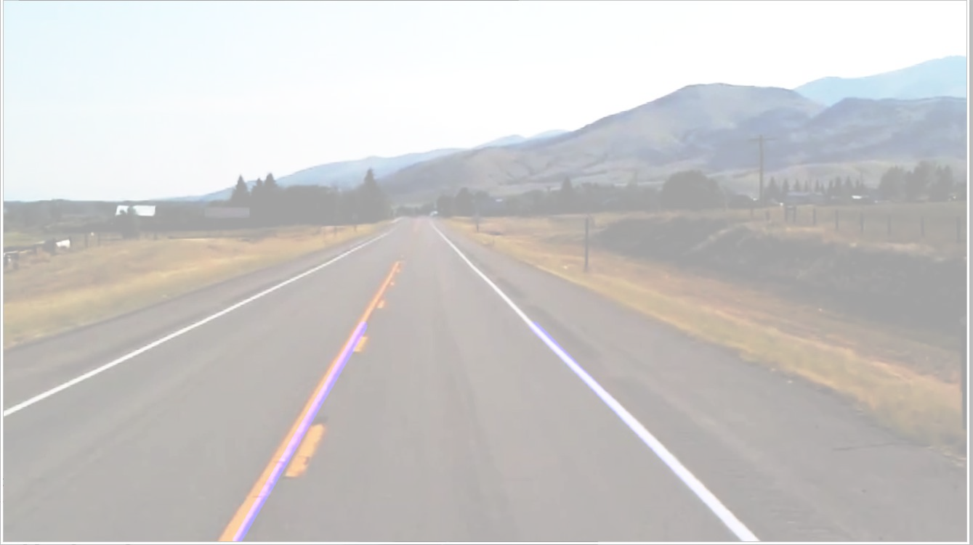LANE DETECTION

SYSTEM

# DATTA MEGHE COLLEGE OF ENGINEERING

**AIROLI**

**INFORMATION TECHNOLOGY**

### MINI PROJECT SEM-IV

#### PREPARED BY:-

NISHANT AVHAD SALVINA DESAI HARISH DOVARI

# INTRODUCTION

#### Autonomous Driving Car is one of the most disruptive innovations in AI. Fuelled by Deep Learning algorithms, they are continuously driving our society forward and creating new opportunities in the mobility sector. An autonomous car can go anywhere a traditional car can go and does everything that an experienced human driver does. But it’s very essential to train it properly. One of the many steps involved during the training of an autonomous driving car is lane detection, which is the preliminary step. Today, we are going to learn how to perform(work) on lane detection.

LANE DETECTION INVOLVES IN FOLLOWING STEPS:-

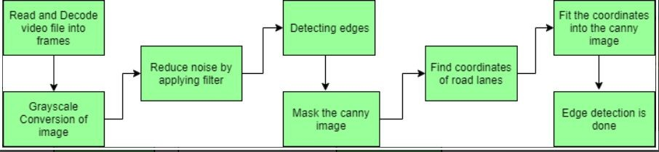

**Look into the project:-**

1. Capturing and decoding video ﬁle:
2. Grayscale conversion of image:
3. Reduce noise:
4. Canny Edge Detector:
5. Region of Interest:
6. Hough Line Transform:
7. Basics of Houghline Method
8. Program content
9. Advantages
10. Disadvantages
11. Future of scope
12. Reference
13. Conclusion

##### Capturing and decoding video ﬁle:

We will capture the video using VideoCapture object and after the capturing has been initialized every video frame is decoded (i.e. converting into a sequence of images).

##### Grayscale conversion of image:

The video frames are in RGB format, RGB [0-255]is converted to grayscale because processing a single channel image is faster than processing a three-channel coloured image.

##### Reduce noise:

Noise can create false edges, therefore before going further, it’s imperative to perform image smoothening. Gaussian ﬁlter is used to perform this process.

##### Canny Edge Detector:

It computes gradient in all directions of our blurred image and traces the edges with large changes in intensity.[The objective of the program given is to perform edge detection of images in real-time. the canny edge detection algorithm is used to detect a wide range of edges in images. OpenCV has in-built function cv2.Canny() which takes our input image as ﬁrst argument and its aperture size(min value and max value) as last two arguments.

###### Region of Interest:

This step is to take into account only the region covered by the road lane. A mask is created here, which is of the same dimension as our road image. Furthermore, bitwise AND operation is performed between each pixel of our canny image and this mask. It ultimately masks the canny image and shows the region of interest traced by the polygonal contour of the mask.

###### Hough Line Transform:

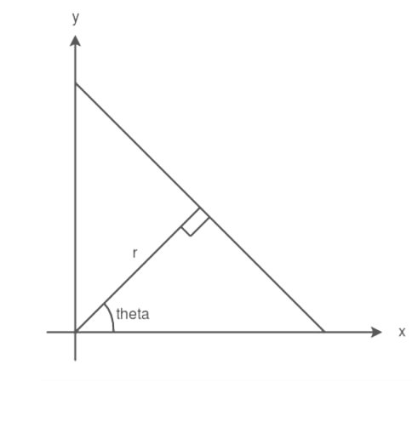The Hough Line Transform is a transform used to detect straight lines. The Probabilistic Hough Line Transform is used here, which gives output as the extremes of the detected lines. The Hough Transform is a method that is used in image processing to detect any shape, if that shape can be represented in mathematical form. It can detect the shape even if it is broken or distorted a little bit.Lines = cv2. houghlinesP (canny_edges, rho, theta, threshold, min_line_lenght, max_line_gap)Rho: Distance of P(pixels). Minimum value of 1. Higher rho = increased distance resolution.Theta: angular resolution. Higher theta = higher angular resolution

We will see how Hough transform works for line detection using the HoughLine transform method. To apply the Houghline method, ﬁrst an edge detection of the speciﬁc image is desirable. For the edge detection technique go through the article Edge detection.

###### Basics of Houghline Method:

A line can be represented as y = mx + c or in parametric form, as r = xcosθ + ysinθ where r is the perpendicular distance from origin to the line, and θ is the angle formed by this perpendicular line and horizontal axis measured in

counter-clockwise ( That direction varies on how you represent the coordinate system. This representation is used in OpenCV). Houghline Method

So Any line can be represented in these two terms, (r, θ).

# PROGRAM CONTENT

1. Lane lines
2. Finding lane lines(Grayscale Conversion)
3. Finding lane lines(Gaussian Blur)
4. Finding lane lines(Using Canny)
5. Finding lane lines(Region of Interest)
6. Finding lane lines(Bitwise_and)
7. Hough transform
8. Lane Lines

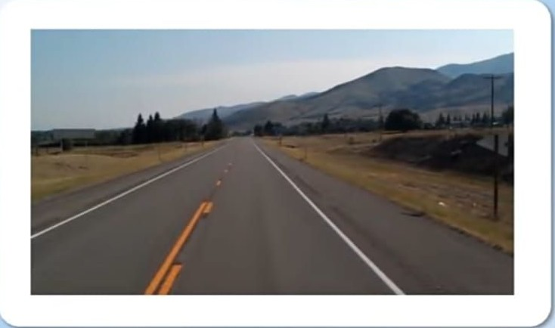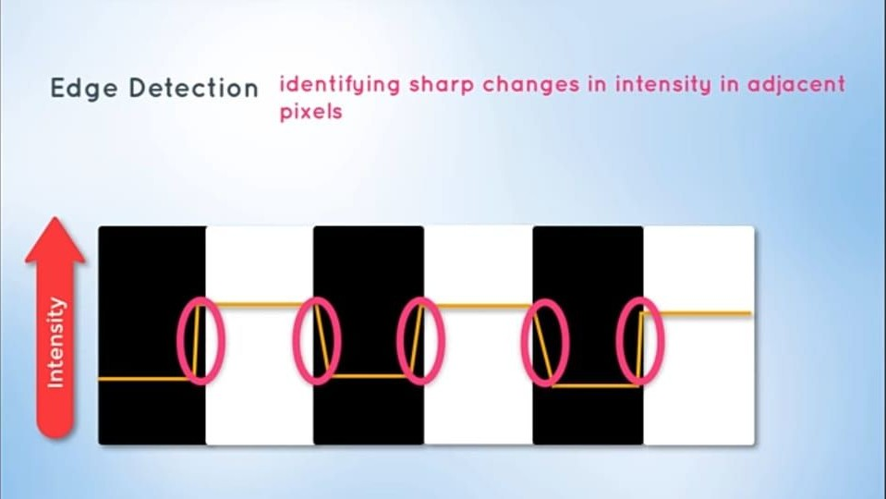

1. Finding lane lines(Grayscale Conversion)
2. Finding lane lines(Gaussian Blur)

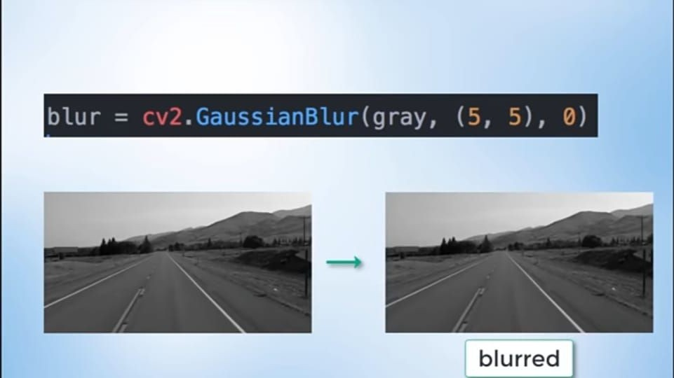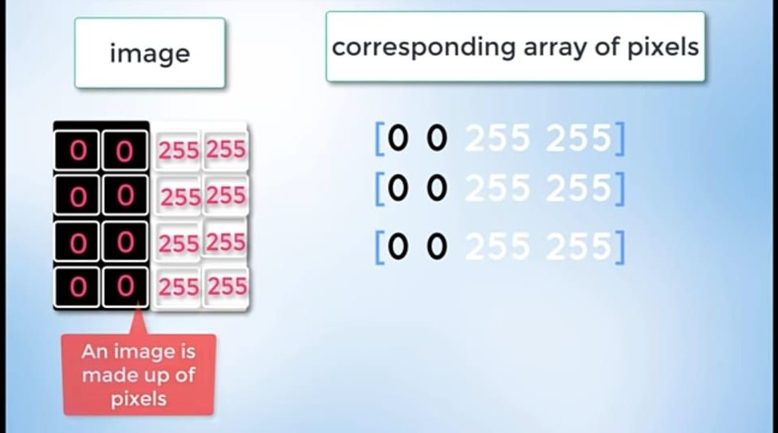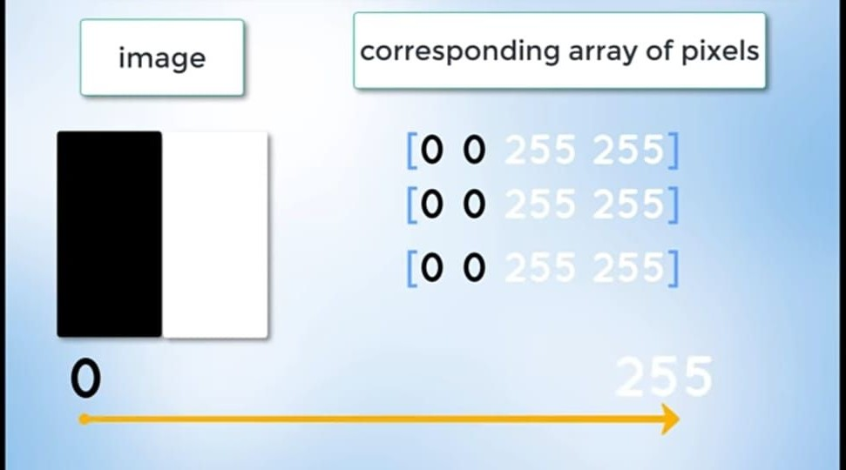

1. Finding lane lines(Using Canny)
2. Finding lane lines(Region of Interest)

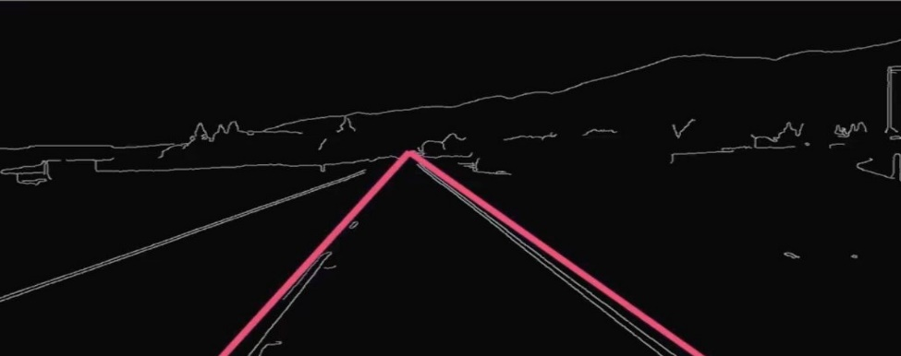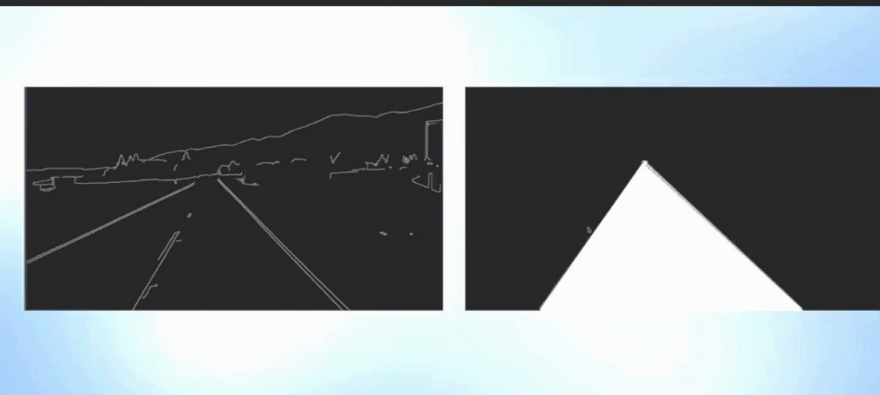

1. Finding lane lines(Bitwise_and)
2. Hough transform

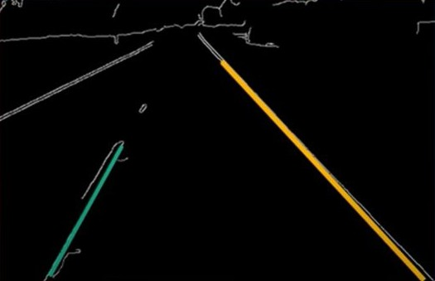

★ CANNY EDGE DETECTION

* + Used to detect boundaries of an image.
  + Uses differential of pixel values.
  + Three regions:-
  + A: Pixel higher than upper threshold = edge(kept)
  + B: Pixel between high and low is accepted if connected to edge
  + C: Pixel below low rejected
  + Recommend 1:2 or 1:3 Low :High threshold ratio

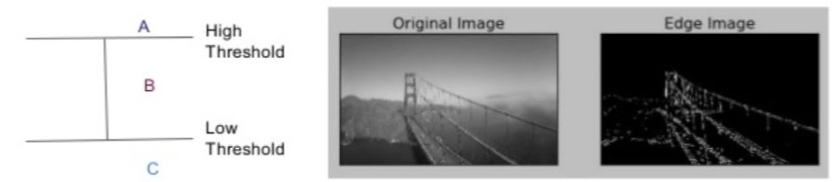

## ★ MASKED IMAGE

* We want to narrow down our analysis to a section of the image.
* Apply a trapezoidal mask over edges
* Use bitwise AND to return image only where mask pixels are non-zero.

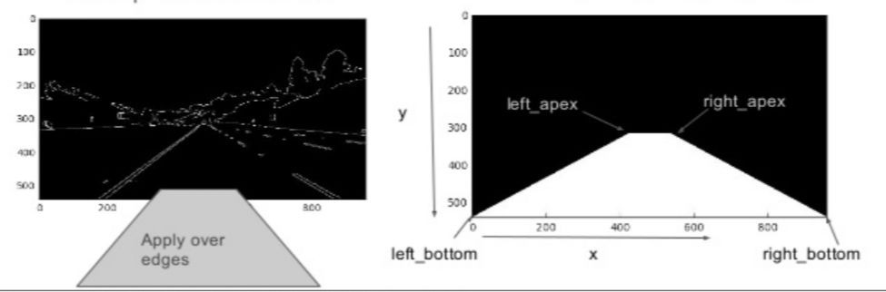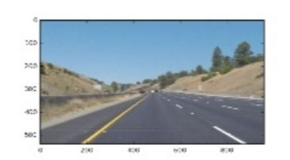

**ADVANTAGES:-**

1. Lane detection system must be able to detect all manner of markings from roadways and ﬁlter them to produce a reliable estimate of the vehicles position relative to the lane.
2. Everybody in this world is concerned about safety. The people those go out from one place to other, They expect to reach safely. Without any sudden incidents which may come through externally by road accidents while travelling. That’s why in order to increase safety and reducing road accidents, people are spending lots of money for the advancement in the driving techniques which ensures the safety.
3. In advanced driver assistance systems desired safety on roads, the complex and challenging tasks of future road vehicles are road lanes detection or boundaries detection. Object detection and tracking the proposed heuristic method is more effective for detect and track of single or multiple vehicles at a time without any distortion and collision.

**DISADVANTAGES:-**

1. The disadvantages of this system are there is faulty detection in curvy roads and wrong detection due to shadows.
2. It does not give well accurate results
3. It cannot detect changes in line
4. High computational complexity
5. Processing time depend on the number of edge pixels and pre-speciﬁed road model.

## FUTURE SCOPE:

* + Safety and comfort application
  + Security of vehicles
  + Communication will be improved to larger extent
  + Long distance driving experiments
  + Large scale scenarios to impact road trafﬁc conditions.

# REFERENCES:

<https://www.geeksforgeeks.org/opencv-real-time-road-lane-detection/>

<https://www.slideshare.net/JonathanMitchell21/computer-vision-lane-line-detection-70638685>

<https://youtu.be/eLTLtUVuuy4>

# CONCLUSION

It was really good experience learning new codes and new methods for lane detection.

The lane detection has proved to be an efﬁcient technique to prevent accidents in intelligent transportation systems but, at the same time we identiﬁed various limitation for lane detection like:-

* Camera Vibration
* Weather Condition
* Poor road condition
* Infrastructure Shadow

The lane detection has shown that the most of the researchers has neglected the problems of the fog and noise. Thus noise and fog may reduce the accuracy of the existing systems.

One can use bilateral ﬁlter and dark channel prior methods to improve the results, In future we will propose a new technique which will integrate the performance of lane detection.

**THANK YOU**